

**A MINI PROJECT REPORT ON**

**GUN OXIMETER**

SUBMITTED TO THE SAVITRIBAI PHULE PUNE UNIVERSITY, PUNE

IN THE PARTIAL FULFILLMENT OF THIRD YEAR OF ENGINEERING

**IN**

**ELECTRONICS AND TELECOMMUNICATION**

**BY**

|  |  |
| --- | --- |
| **VAISHNAVI V. DESHMUKH** | **PRN No. 72023821J** |
| **PRANAV R. ARJUN** | **PRN No. 72023742E** |

**UNDER THE GUIDANCE OF**

**Dr. V.K. Bairagi**

**ACADEMIC YEAR: 2021-22**

**CERTIFICATE**

This is to certify that Project Report entitled

**“*GUN OXIMETER*”**

Submitted by

***Ms. VAISHNAVI V. DESHMUKH* (*PRN No. 72023821J*)**

***Mr. PRANAV R. ARJUN******(PRN No.72023742E*** ***)***

is the record of bonafide work carried out by them in partial fulfillment of the requirement for the award of the Degree of **Bachelor of Engineering (Electronics and Telecommunication),** as prescribed by the Savitribai Phule Pune University in the Academic Year 2020-21.

This mini project report has not been earlier submitted to any other Institute or University for the award of any degree or diploma*.*

|  |  |  |
| --- | --- | --- |
| **Dr. V.K. Bairagi** | **Dr. M.P. Sardey** | **Dr. P.B. Mane** |
| Internal Guide | Head of Department | Principal |
| **Department of E&TC Engg.** | **Department of E&TC Engg.** | **AISSMS** |
|  |  | **Institute of Information Technology Pune.** |
|  |  |  |
| Date: | . |  |
|  |  |  |

**Acknowledgement**

It is my great pleasure in expressing sincere and deep gratitude towards my guide **Mr. V. K. Bairagi ,** Electronics & Telecommunication Engineering Department for his valuable guidance and Project coordinator **Mr. Sugat Pawar** for his constant support throughout this work and help to peruse additional studies in electronics and telecommunication.

We take this opportunity to thank Head of the Department **Dr.M.P. Sardey** and all staff members of department of Electronics &Telecommunication Engineering AISSMS IOIT, Pune, for cooperation provided by them in many ways.

The motivation factor for this work was the inspiration given by our honorable principal **Dr. P.B. Mane.**

Lastly, I am thankful to those who have directly or indirectly supported for our work.

Sign Sign

***Ms. VAISHNAVI V. DESHMUKH Mr. PRANAV ARJUN***

|  |  |  |
| --- | --- | --- |
| **Sr No.** | **TITLE** | **PAGE NO.** |
| **1 a** | **List of Figures** | **5** |
| **1 b** | **Abstract** | **6** |
| **2** | **Introduction** | **7** |
| **3** | **Literature review** | **8** |
|  | Review of patents |  |
|  | Review of research paper |  |
| **4** | **Aim and Objective** | **12** |
|  | Problem statement |  |
|  | Objectives |  |
|  | Methodology |  |
|  | Specification of the system |  |
| **5** | **Block diagram of the system and its explanation** | **15** |
| **6** | **Hardware design** | **16** |
|  | Construction and circuit diagram |  |
|  | Operation of solar tracker |  |
|  | Assumption and limitations |  |
| **7** | **Software design** | **25** |
|  | Modules |  |
|  | Diagrams |  |
|  | Feasibility study |  |
| **8** | **Result and analysis** | **35** |
| **9** | **Challenges and Conclusion** | **38** |
| **10** | **Appendix** | **39** |
|  | References & Bill of material |  |
|  | Datasheets |  |

**INDEX**

|  |  |  |
| --- | --- | --- |
| **FIGURE NO** | TITLE | **PAGE NO** |
| 1 | Gun Oximeter | 6 |
| 2 | Block diagram | 15 |
| 3 | Data Flow Diagram | 15 |
| 4 | Circuit Diagram | 24 |
| 5 | Django work flow diagram | 26 |
| 6 | Web page photos | 33 |
| 7 | Temperature accuracy graph | 36 |
| 8 | Oxygen accuracy graph | 36 |
| 9 | My SQL workbench data | 37 |
|  |  |  |
|  |  |  |
|  |  |  |
|  |  |  |
|  |  |  |
|  |  |  |
|  |  |  |

**LIST OF FIGURES**

**ABSTRACT**

Gun oximeter is a IOT based project which can we very useful in pandemic and post pandemic period. The COVID-19 virus has changed the lifestyle of people in every way. But coping with this virus we have to take precautions.

High temperature and Low oxygen which are the most primary signs needs to checked frequently at public places. For this Gun Oximeter which is a combination of Temperature Gun and Oximeter , will be very useful.

Gun Oximeter contains two main sensors , IR temperature sensor and Spo2 sensor which helps us detect two parameters using single device.

More over we have integrated this hardware with a Web Application. Web Application totally changes the picture of traditional measuring systems. The sensor data which is collected at public places is displayed on a web page . Here one can store the data along with the person’s information.

The sensor data + person’s information is stored in an organized way so that this data can be further used for any type of analysis.

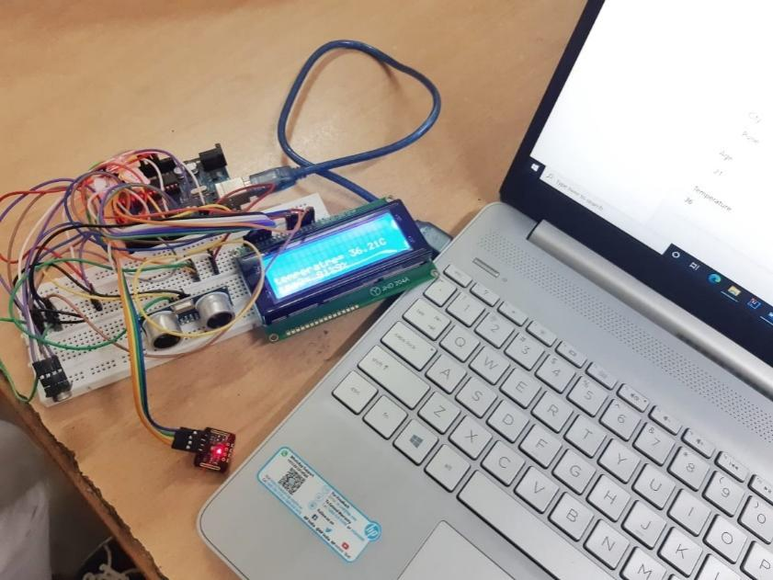

**Fig.1** Gun Oximeter Circuit

**INTRODUCTION**

Deadly corona virus changed our lifestyle in every way. We are stuck in our houses. Once we step out for work we are in constant danger of getting infected. But we have to find a feasible way to live with this new lifestyle. While adjusting to the rush one must take into account that Corona Virus is not yet over.

And neither it will be totally eradicated. Government are making several attempts to make sure every person is aware of the basic things which can help us protect from getting affected.

High Temperature and Low Oxygen level are primary signs of infected person.

Often times people are not aware that they are infected unless their O2 levels are checked.

At the public places only temperature is checked. Oxygen level is totally neglected. Oxygen level is more important as it tells the severity of the infection. There are the cases where due to normal temperature but very low oxygen level, people are getting into serious conditions.

There are several places where currently measuring oxygen saturation level is ignored. This is due to several problems

1. Problem of handling two instruments at same time.
2. Cost of the two devices is more.
3. There is also carelessness among the people.
4. Unawareness among the people.

However even though if the temperature is measured , no proper record is kept. A hard copy is used by the security guards , which is not a proper way of storing the data. There is actually no use of measuring the temperature as the data is neglected.

This data is very useful while making the data analysis of covid patients. One can use this data to check which area is in red zone , which age group is most affected etc.

Gun Oximeter is a device where one can measure both temperature and oxygen at public place . Not only this we can store this sensor data in organized way in a database along with the person’s information which can be retrieved easily.

**LITERATURE REVIEW**

1. **Quast, S.; Kimberger, O. The Significance of Core Temperature— Pathophysiology and Measurement Methods; Dräger Medical GmbH: Lübeck, Germany, 2014.**

Infrared thermometry is a mature but dynamic technology that has gained the respect of many industries and institutions. It is an indispensable technique for many temperature measurement applications, and the preferred method for some others.

Infrared thermometers for non-contact temperature measurement are highly developed sensors which have wide-spread application in industrial processing and research. Infrared thermometers (IRT) are fast, convenient and ease to use.

Two types of infrared thermometers are uses to measure body temperature: tympanic and forehead.

The performance of this type of device and the criteria for screening are worth studying.

1. **Hsuan-Yu Chen, Andrew Chen, Chiachung Chen, Investigation of the Impact of Infrared Sensors on Core Body Temperature Monitoring by Comparing Measurement Sites, MDPI, Basel, Switzerland, May 2020**

The important formulas are as follows: Kirchoff's Law When an object is at thermal equilibrium, the amount of absorption will equal the amount of emission.

Infrared Temperature Measurement The modern IRT is founded on this concept, but is more technologically sophisticated to widen the scope of its application.

This technique is not dissimilar to the infrared thermometers described so far, but measures the ratio of infrared energy emitted from the material at two wavelengths, rather than the absolute energy at one wavelength or wave band.

The measurement values for wrist temperature show significant offsets with the tympanic temperature and cannot be used to screen fevers.

1. **Wukitsch MW, Petterson MT, Tobler DR, Pologe JA. Pulse oximetry: analysis of theory, technology, and practice. J Clin Monit. 1988;4:290–301. doi: 10.1007/BF01617328.**

The oximetric measurement of oxygen concentration in blood has been a valuable tool since it became commercially available in the United States in the early 1970's. Generally, an oximeter is a photoelectric instrument that continually measures the oxygen content of blood or oxygen saturation in a person by measuring the intensity of a light beam transmitted through body tissue. Oxygen saturation is numerically displayed as a percentage, and is typically accompanied by an audible alarm if the current value is outside present limits of acceptable saturation. Motion artifact continues to be a significant source of error and false alarms [35,36,37,38].

When tested in healthy volunteers during standardized motion, Masimo SET™ exhibited much lower error rates (defined as percentage of time that the oximeter error exceeded 5%, 7%, and 10%) and dropout rates (defined as the percentage of time that the oximeter provided no S p O 2 data) than did the Nellcor N-200 and Nellcor N-3000 oximeters (Nellcor Puritan Bennett, Pleasanton, California, USA)for all test conditions [45].

**REVIEW OF PATENTS**

1. US6129673A - Infrared thermometer - Google Patents

To overcome the limitations of the prior art, the invention provides a method and system for performing non-contact temperature measurement of an object accurately and efficiently.

In addition to the ambient T a , the first thermistor 19 is positioned within the chamber to be exposed to the waveguide 15 and, consequently, to IR radiation entering the probe 4 through the window 17.

1. DE19526556A1 - Infrared temperature sensor - Google Patents

Infrared temperature sensors advantageously do not require any Surface contact, but instead use an infrared detector, the infrared light gets from the place where a temperature measurement should be done. Appropriate electronics with the infrared sensor is connected, determines the temperature at the desired location.

1. US4883353A - Pulse oximeter - Google Patents

BACKGROUND OF THE INVENTION This invention relates to displaying the process used by a pulse oximeter for identifying the maximum and minimum values of pulsatile waveforms in order to determine the amplitudes used for calculating oxygen saturation.

Under most operating conditions, the upper envelope and lower envelope will correctly track the peaks and valleys of the pulsatile waveform, indicating an accurate processing of saturation of oxygen percentile.

A pulse oximeter in accordance with claim 2 wherein said displayable process waveform comprises: an upper envelope for tracking the process of determining said maximum value of the pulsatile waveform; and a lower envelope for tracking the process of determining said minimum value of the pulsatile waveform.

1. EP2750604B1 - Wearable pulse oximetry device - Google Patents

TECHNICAL FIELD The present invention relates to systems and methods for pulse oximetry measurements at the wrist, particularly, the present invention relates to a pulse oximetry device that can be worn on a wrist.An increased optical path length, as provided by the configuration of the oximeter 30, brings about an increase of interaction between the propagating light and surrounding tissue for ultimately providing a robust signal from which pulse oximetry data can be obtained.

Indeed, a correlation of step 206 is found to be below a specified threshold or criteria (for example <0.8), the process flow moves from decision junction 206 to step 208, where a moving regression algorithm is implemented by the oximeter 70 for rejecting those data signals indicative of artifacts arising out of user motion.

In other embodiments of the present technique, the wrist-band type oximeter utilizes a system for detecting and/or mitigating signal artifacts arising out user motion, for example, hand motion, thereby achieving a reliable pulse oximetry measurement.

**AIM AND OBJECTIVE**

**Problem Statement:** To design a single device which can measure the temperature and oxygen of people in public places. Storing this data in organized way on database for further analysis.

**Aim**

The motive of Gun Oximeter is to make the process of measuring temperature and oxygen of people at public places much easier , faster and safer. Along with this storing the data collected from public places in such organized way so that it can be used for data analysis in future.

**Objectives:-**

1. To design two in one device for accurate measurement of temperature and oxygen .
2. To interface the various sensors for detection with the microcontroller.
3. To collect the sensor data (temperature, oxygen saturation readings.) in proper format.
4. To build a Web Application where the sensor data will be stored along with person’s information.
5. To migrating this data in Database where it can be stored properly.
6. To interface hardware with software webapp, collecting the sensor readings and storing it for further analysis.

**METHODOLOGY:**

1. The project is divided into two parts. Hardware and Software.
2. Gun Oximeter works on two main sensors. IR Temperature detection sensor (MLX90614) and SPO2 Oxygen saturation sensor (MAX30102).
3. Both the sensors are interfaced with the Arduino Board . Measurements of the person ; temperature and oxygen readings are taken on the Arduino IDE.
4. The temperature and Spo2 reading are collected from the sensors and are then sent to the Python terminal.
5. Here the interfacing of Arduino with Python is done. The readings taken from sensors are displayed on the python terminal.
6. In this project Web Application is built using Django Framework. Here the readings are sent to a form.
7. This form contains several other fields related to person’s information such as name, age, area , vaccination status etc.
8. Once the form is filled completely the data of the person along with the readings are saved in a database.
9. This allows us to use the information for further analysis.

**SPECIFICATION OF THE SYSTEM: -**

1. **Temperature sensor (MLX90614):**

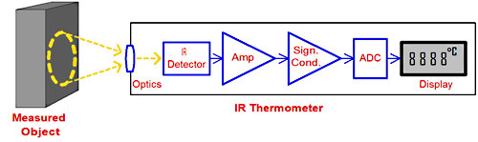

Infrared thermometers employ a lens to focus the infrared light emitting from the object onto a detector known as a thermopile.  
  
The thermopile is nothing but thermocouples connected in series or parallel. When the infrared radiation falls on the thermopile surface, it gets absorbed and converts into heat. Voltage output is produced in proportion to the incident infrared energy. The detector uses this output to determine the temperature, which gets displayed on the screen.

1. **Spo2 sensor (MAX30102):**

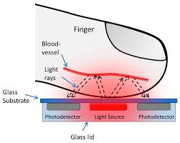

Pulse oximetry is simple to carry out; it only uses two different light sources and a [photodiode](https://www.sciencedirect.com/topics/engineering/photodiode) . Depending on the measurement site, either the transmissive or the reflective mode can be used. In the transmissive mode, the light sources and photodiode are opposite to each other with the measurement site between them. Light then passes through the site. In the reflective mode, the light sources and photodiode are on the same side, and light is reflected to the photodiode across the measurement site.

**Detailed Specifications:**

1. Operating Voltage= 5V
2. Operating temperature = Room temperature.
3. Spo2 sensor **MAX30102** =
   1. Power supply 3.3V to 5.5V
   2. Current draw ~600μA (during measurements)

~0.7μA (during standby mode)

* 1. IR LED Wavelength 880nm
  2. Red LED Wavelength 660nm

1. Temperature sensor **MLX90614** =
   1. Operating Voltage: 3.6V to 5V (available in 3V and 5V version)
   2. Supply Current: 1.5mA
   3. Object Temperature Range: -70° C to 382.2°C
   4. Ambient Temperature Range: -40° C to 125°C
2. Efficiency = 40% to 60% more than static solar panel.
3. Communication Interface= USB or any external power source
4. Tracking Accuracy= -5% to +5% error can be induced.

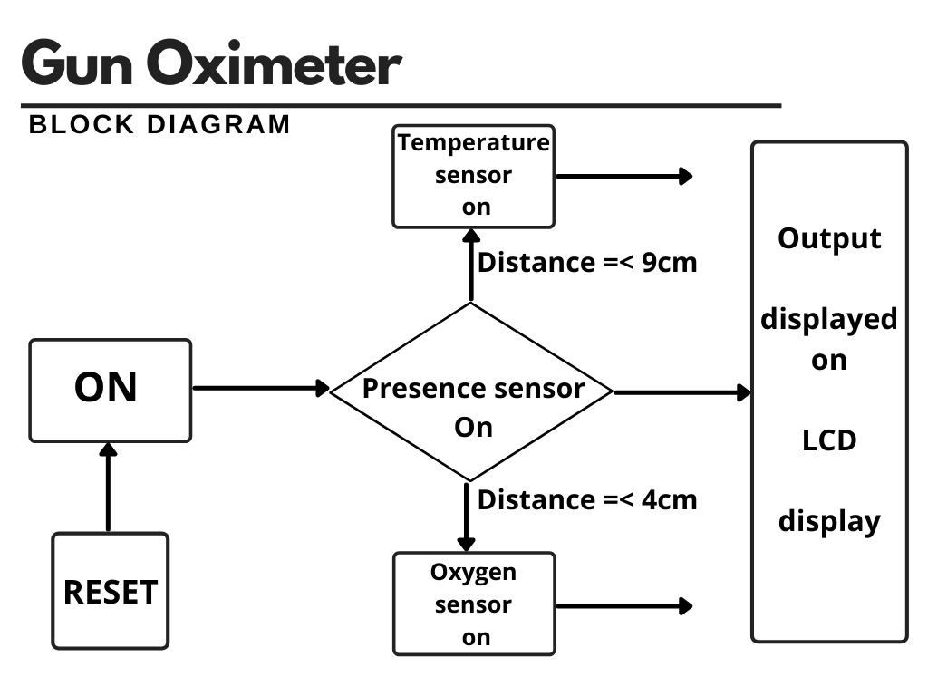

**Fig 2** BLOCK DIAGRAM OF THE SYSTEM

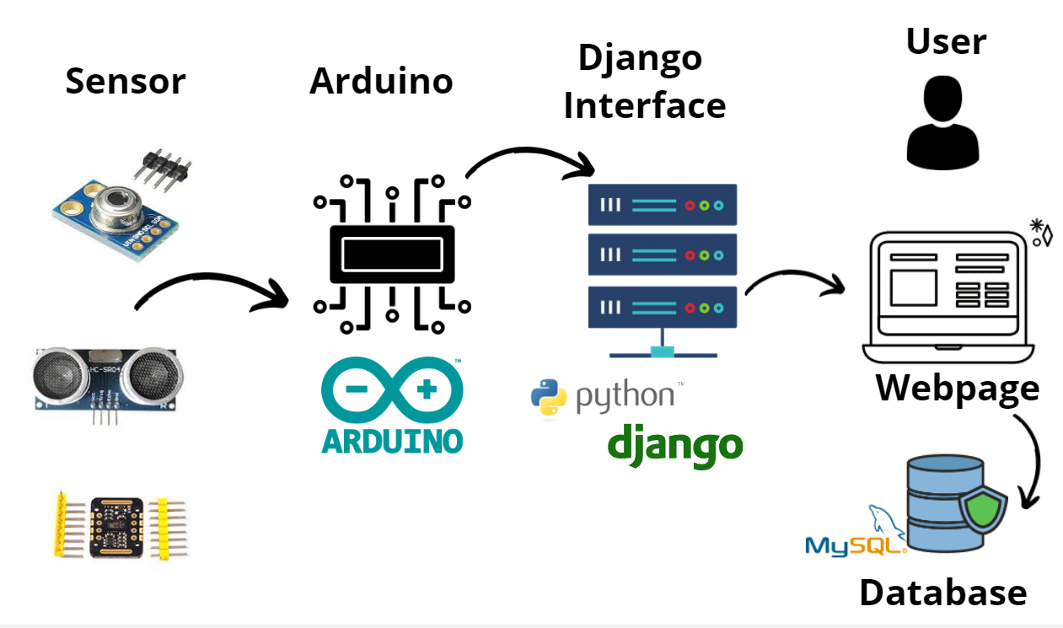

**Fig 3** Data Flow Diagram

**Hardware Design**

In this project we have used following hardware components:

1. Arduino UNO R3 board.
2. Temperature Sensor (MLX90614)
3. SPO2 Sensor (Max30102)
4. 20x4 LCD Display
5. Breadboard
6. Jumper Wires.

**1.Arduino Uno R3**:-

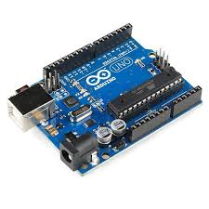The Arduino Uno R3 is a microcontroller board based on a removable, dual inline-package (DIP) ATmega328 AVR microcontroller. It has 20 digital input/output pins (of which 6 can be used as PWM outputs and 6 can be used as analog inputs). Programs can be loaded on to it from the easy-to-use Arduino computer program. The Arduino has an extensive support community, which makes it a very easy way to get started working with embedded electronics. The R3 is the third, and latest, revision of the Arduino Uno.

* Serial Pins 0 (Rx) and 1 (Tx): Rx and Tx pins are used to receive and transmit TTL serial data. They are connected with the corresponding ATmega328P USB to TTL serial chip.
* External Interrupt Pins 2 and 3: These pins can be configured to trigger an interrupt on a low value, a rising or falling edge, or a change in value.
* PWM Pins 3, 5, 6, 9 and 11: These pins provide an 8-bit PWM output by using analogWrite() function.
* SPI Pins 10 (SS), 11 (MOSI), 12 (MISO) and 13 (SCK): These pins are used for SPI communication.
* In-built LED Pin 13: This pin is connected with a built-in LED, when pin 13 is HIGH – LED is on and when pin 13 is LOW, its off.
* AREF: Used to provide reference voltage for analog inputs with analogReference() function.
* Reset Pin: Making this pin LOW, resets the microcontroller.

**2.Temperature Sensor (MLX90614)**:-

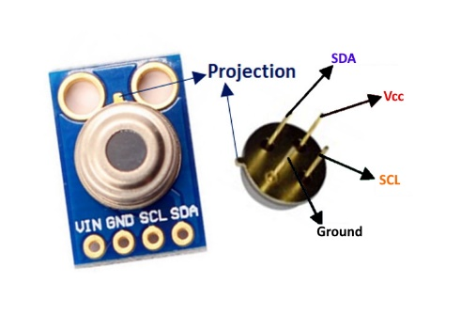The MLX90614 is a **Contactless Infrared (IR) Digital Temperature Sensor**that can be used to measure the temperature of a particular object ranging from -70° C to 382.2°C. The sensor uses IR rays to measure the temperature of the object without any physical contact and communicates to the microcontroller using the I2C protocol.

**MLX90614 Pinout Configuration**

|  |  |  |
| --- | --- | --- |
| **Pin No.** | **Pin Name** | **Description** |
| 1 | Vdd (Power supply) | Vdd can be used to power the sensor, typically using 5V |
| 2 | Ground | The metal can also act as ground |
| 3 | SDA – Serial Data | Serial data pin used for I2C Communication |
| 4 | SCL – Serial Clock | Serial Clock Pin used for I2C Communication |

**MLX90614 Temperature Sensor Specifications**

* Operating Voltage: 3.6V to 5V (available in 3V and 5V version)
* Supply Current: 1.5mA
* Object Temperature Range: -70° C to 382.2°C
* Ambient Temperature Range: -40° C to 125°C
* Accuracy: 0.02°C
* Field of View: 80°
* Distance between object and sensor: 2cm-5cm (approx.)

**3.Oxygen Saturation Detection Sensor (MAX30102)**:-

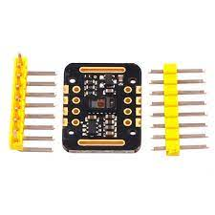The MAX30102 is an integrated pulse oximetry and heart-rate monitor module. It includes internal LEDs, photodetectors, optical elements, and low-noise electronics with ambient light rejection.

The module features the MAX30102 – a modern (the successor to the [MAX30100](https://lastminuteengineers.com/max30100-pulse-oximeter-heart-rate-sensor-arduino-tutorial/)), integrated pulse oximeter and heart rate sensor IC, from Analog Devices. It combines two LEDs, a photodetector, optimized optics, and low-noise analog signal processing to detect pulse oximetry (SpO2) and heart rate (HR) signals.

Behind the window on one side, the MAX30102 has two LEDs – a RED and an IR LED. On the other side is a very sensitive photodetector. The idea is that you shine a single LED at a time, detecting the amount of light shining back at the detector, and, based on the signature, you can measure blood oxygen level and heart rate.

1. **Technical Specifications**

|  |  |
| --- | --- |
| Power supply | 3.3V to 5.5V |
| Current draw | ~600μA (during measurements) |
| ~0.7μA (during standby mode) |
| Red LED Wavelength | 660nm |
| IR LED Wavelength | 880nm |
| Temperature Range | -40˚C to +85˚C |
| Temperature Accuracy | ±1˚C |

**4.Liquid Crystal Display (20x4)**:-

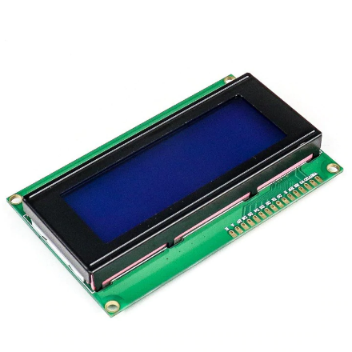A 20x4 LCD display is very basic module and is very commonly used in various devices and circuits. These modules are preferred over seven segments and other multi segment LEDs. The reasons being: LCDs are economical; easily programmable; have no limitation of displaying special & even custom characters (unlike in seven segments), animations and so on.

A **20x4 LCD** means it can display 20 characters per line and there are 4 such lines. In this LCD each character is displayed in 5x7 pixel matrix. This LCD has two registers, namely, Command and Data. This is standard HD44780 controller LCD.

There is no change code for interfacing standard 16x2 or 20x4 LCD.

1. 20 Characters x 4 Lines
2. Built-in HD44780 Equivalent LCD Controller
3. Works directly with ATMEGA, ARDUINO, PIC and many other microcontroller /kits.
4. 4 or 8 bit data I/O interface
5. Low power consumption

* **Pin Configuration**

|  |  |  |
| --- | --- | --- |
| **Pin No:** | **Pin Name:** | **Parameters** |
| Pin#1 | It denoted as Vss | It is ground pinout potential at this pinout is zero. |
| Pin#2 | It denoted as Vdd | At this pinout, five volts are provided. |
| Pin#3 | This pinout denoted as Vo | This pinout is used to set the contrast of the screen. |
| Pin#4 | This pin denoted as RS | It used to H/L register select signal. |
| Pin#5 | It denoted as R/W | It used for H/L read/write signal. |
| Pin#6 | This pinout denoted as E | It used for H/L enable signal. |
| Pin#7-14 | The pinouts from seven to fourteen denoted as DB0 – DB7. | It used for H/L data bus for 4 bit or 8-bit mode. |
| Pin#15 | It identified as A (LED+) | It used to set backlight anode. |
| Pin#16 | It recognized as K (LED-). | It used to set backlight cathode. |

**WORKING OF GUN OXIMETER.**

* In the Gun oximeter, Ultrasonic sensor detects the Human Presence. Once a Object is detected at certain distance Gun Oximeter is switched on.
* After switching on , when object is at particular distance, temperature sensor gets activated and temperature is displayed on LCD display.
* Then after temperature , person is asked to get more closer to the gun oximeter for SPo2 detection. After standing at particular distance , SPO2 sensor gets activated and spo2 level is displayed.
* The distances for which the sensors should switched on and off can be decided by user.after the data is being captured it is then sent to the python server.
* The Python server will then send the data to the Django Web page .
* Once the temperature and spo2 readings are displayed on the webpage the user can then enter the person’s information.
* After the form is filled it is submitted . This data is saved in the MySQL database.
* This data can be used for future uses.

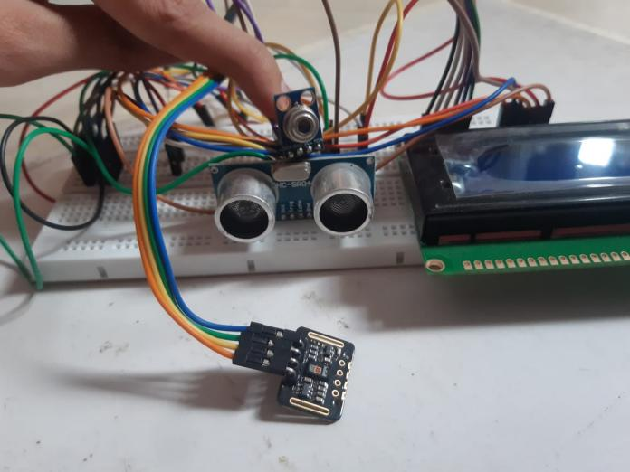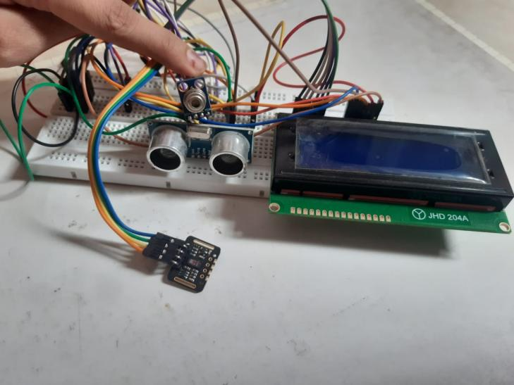

**Fig 4** Circuit Diagram

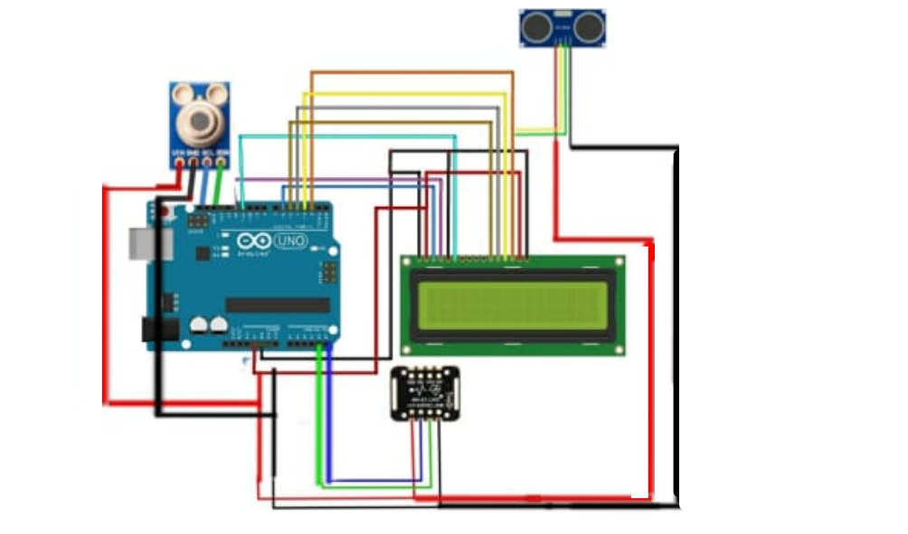

**Software design**

We have used Django framework for building the website which can display and store the data

What is the Django Framework?

Django is an open-source python web framework used for rapid development, pragmatic, maintainable, clean design, and secure websites. A web application framework is a toolkit of all components needed for application development.

The main goal of the Django framework is to allow developers to focus on components of the application that are new instead of spending time on already developed components. Django is fully featured than many other frameworks on the market. It takes care of a lot of hassles involved in web development; enables users to focus on developing components needed for their application.

Top 5 Uses of Django

1. Easy to Use

2.It’s fast and simple

3. Excellent Documentation for real-world application

4. It’s secure

5. It suits any web application project

**The Django MTV architecture is composed of the following components:**

* Model: it defines the logical data structure. In practice, a model is a Python class, which represents a single table in the database. All the classes representing the logical structure of the database are stored in a script named models.py.
* View: it defines the business logic, in the sense that it communicates with the model and translates it into a format readable by the Template. A view is a Python function, which takes a request as input and returns a Web response as output. All the functions representing the business logic are stored in a script named views.py.
* Template: it defines the structure or the layout of a file, such as a HTML file. It is a text document or a Python string encoded through the Django template language.

The following figure illustrates the Django MTV architecture and how the Model, Template and View components interact each other:

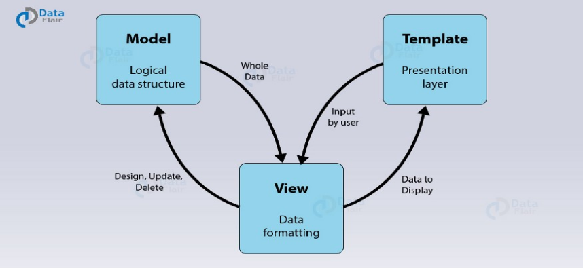

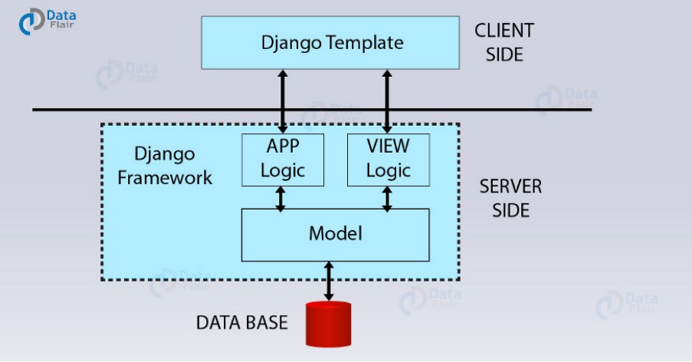

**Fig 5** Django Work Flow

As from the above diagram, we have some components and two regions i.e., server side and client side. Here you will notice that the View is on the server-side part while the template is on the client side.

Now, when we request for the website, the interface through which we use to make that request via our browser was the Template. Then that request transmits to the server for the management of view file.

Django is literally a play between the requests and responses. So whenever our Template is updating it’s the input (request) we sent from here which on the server was seen by the View. And, then it transports to the correct URL. It’s one of the important components of Django MTV architecture. There, the URL mapping in Django is actually done in regular expressions. These expressions are much more understandable than IP addresses. It also helps with the SEO task which we have discussed in the Django Features Tutorial.

Now after the sending of a request to the correct URL, the app logic applies and the model initiates to correct response to the given request. Then that particular response is sent back to the View where it again examines the response and transmits it as an HTTP response or desired user format. Then, it again renders by the browser via Templates.

An easier real-life working of above functioning would be –

When you login in a website ([Django](https://www.djangoproject.com/start/) based), you open the login page. It again happens without the need of the Model. It is because Views will process the request and send it to the URL of the login page. Then, it will be a response by the server, from there to the browser.

After that, you enter your credentials in the given Template, HTML form. From there the data is again sent to the view, this time this request rectifies and the model is given data. Then the Model reads and verifies the data that the user provides within the connected database.

If the user data matches it will send the relevant user data like profile image, name and (other things depending on the type of website) to the Views. It will then format the same in desired response and will transmit the same to the client.

Otherwise, the Model will send a negative result to the Views. In turn, it will rout it to the login page again alongside an error message.

That’s how the Django MTV architecture is actually working.

**Code :**

**1. Arduino Code :**

//GUN OXIMETER.

// Adding libraries

#include <Wire.h>

#include "MAX30105.h"

#include "spo2_algorithm.h"

#include <Adafruit_MLX90614.h>

#include <LiquidCrystal.h>

int Contrast=145;

LiquidCrystal lcd(12, 11, 5, 4, 3, 2);

int temp;

#include<NewPing.h>

const int trigPin = 9;

const int echoPin = 10;

float duration, distance;

Adafruit_MLX90614 mlx = Adafruit_MLX90614();

MAX30105 particleSensor;

#define MAX_BRIGHTNESS 255

#if defined(__AVR_ATmega328P__) || defined(__AVR_ATmega168__)

//Arduino Uno doesn't have enough SRAM to store 100 samples of IR led data and red led data in 32-bit format

//To solve this problem, 16-bit MSB of the sampled data will be truncated. Samples become 16-bit data.

uint16_t irBuffer[50]; //infrared LED sensor data

uint16_t redBuffer[50]; //red LED sensor data

#else

uint32_t irBuffer[50]; //infrared LED sensor data

uint32_t redBuffer[50]; //red LED sensor data

#endif

int32_t bufferLength; //data length

int32_t spo2; //SPO2 value

int8_t validSPO2; //indicator to show if the SPO2 calculation is valid

int32_t heartRate; //heart rate value

int8_t validHeartRate; //indicator to show if the heart rate calculation is valid

byte pulseLED = 11; //Must be on PWM pin

byte readLED = 13; //Blinks with each data read

void setup() {

//LCD Set UP

analogWrite(6,Contrast);

lcd.begin(20, 4);

//Presence Sensor Setup

pinMode(trigPin, OUTPUT);

pinMode(echoPin, INPUT);

Serial.begin(9600);

// //HR and SPO2 Sensor Setup

Serial.begin(9600); // initialize serial communication at 115200 bits per second:

pinMode(pulseLED, OUTPUT);

pinMode(readLED, OUTPUT);

if (!particleSensor.begin(Wire, I2C_SPEED_FAST)) //Use default I2C port, 400kHz speed

{

Serial.println(F("MAX30105 was not found. Please check wiring/power."));

while (1);

}

Serial.read();

byte ledBrightness = 60; //Options: 0=Off to 255=50mA

byte sampleAverage = 4; //Options: 1, 2, 4, 8, 16, 32

byte ledMode = 2; //Options: 1 = Red only, 2 = Red + IR, 3 = Red + IR + Green

byte sampleRate = 100; //Options: 50, 100, 200, 400, 800, 1000, 1600, 3200

int pulseWidth = 411; //Options: 69, 118, 215, 411

int adcRange = 4096; //Options: 2048, 4096, 8192, 16384

particleSensor.setup(ledBrightness, sampleAverage, ledMode, sampleRate, pulseWidth, adcRange);

//Configure sensor with these settings

mlx.begin();

}

void loop() {

digitalWrite(trigPin, LOW);

delayMicroseconds(1000);

digitalWrite(trigPin, HIGH);

delayMicroseconds(1000);

digitalWrite(trigPin, LOW);

duration = pulseIn(echoPin, HIGH);

distance = (duration*.0343)/2;

lcd.clear();

lcd.setCursor(0, 0);

lcd.print(distance);

lcd.print(",");

// Temperature

temp= mlx.readObjectTempC();

//LCD

delay(500);

lcd.clear();

lcd.setCursor(0, 2);

lcd.print("temperatre= ");

lcd.print(mlx.readObjectTempC());

lcd.print("C");

delay(1000);

//SPO2

long irValue = particleSensor.getIR();

bufferLength = 50; //buffer length of 100 stores 4 seconds of samples running at 25sps

//read the first 50 samples, and determine the signal range

for (byte i = 0 ; i < bufferLength ; i++)

{

while (particleSensor.available() == false) //do we have new data?

particleSensor.check(); //Check the sensor for new data

redBuffer[i] = particleSensor.getRed();

irBuffer[i] = particleSensor.getIR();

particleSensor.nextSample();

}

maxim_heart_rate_and_oxygen_saturation(irBuffer, bufferLength, redBuffer, &spo2, &validSPO2, &heartRate, &validHeartRate);

//Continuously taking samples from MAX30102. Heart rate and SpO2 are calculated every 1 second

while (1)

{

//dumping the first 25 sets of samples in the memory and shift the last 75 sets of samples to the top

for (byte i = 15; i < 50; i++)

{

redBuffer[i - 15] = redBuffer[i];

irBuffer[i - 15] = irBuffer[i];

}

//take 25 sets of samples before calculating the heart rate.

for (byte i = 25; i < 50; i++)

{

while (particleSensor.available() == false) //do we have new data?

particleSensor.check(); //Check the sensor for new data

digitalWrite(readLED, !digitalRead(readLED)); //Blink onboard LED with every data read

redBuffer[i] = particleSensor.getRed();

irBuffer[i] = particleSensor.getIR();

particleSensor.nextSample();

if (validSPO2){

Serial.print(distance);

Serial.print(",");

Serial.print(temp);

Serial.print(",");

Serial.print(spo2, DEC);

Serial.println(",");

}

delay(1000);

//LCD

lcd.setCursor(0, 3);

lcd.print("spo2= ");

lcd.print(spo2);

lcd.print("%");

}

maxim_heart_rate_and_oxygen_saturation(irBuffer, bufferLength, redBuffer, &spo2, &validSPO2, &heartRate, &validHeartRate);

}

}

}

**Python Code :**

import serial

import time

import schedule

from django.http import JsonResponse

import numpy as np

def Arduino(request):

arduino = serial.Serial('com3', 9600)

print('Established serial connection to Arduino')

data = arduino.readline()

data = str(data,'utf')

data=data.strip('\r\n')

data=data.split(",")

# Decalring the varibales

dist=(data[0])

temp = (data[1])

spo2 = (data[2])

arduino.close()

return JsonResponse({'temp': temp, 'spo2': spo2})

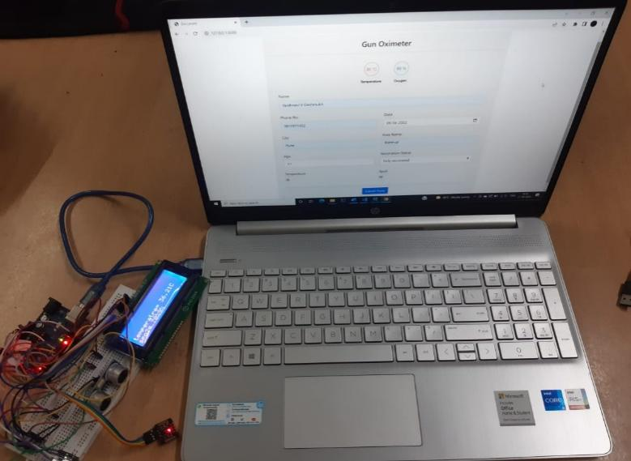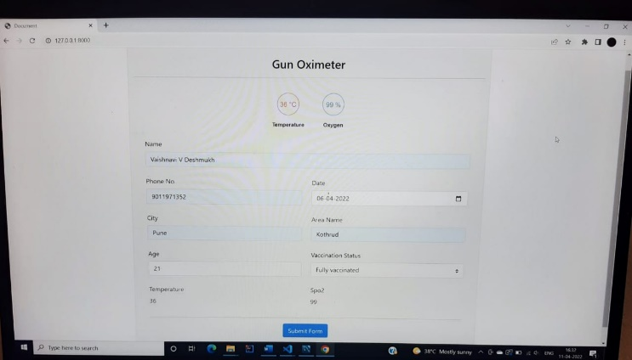

**Fig 6** Web Page and Interfacing hardware with software.

**Feasibility Study:**

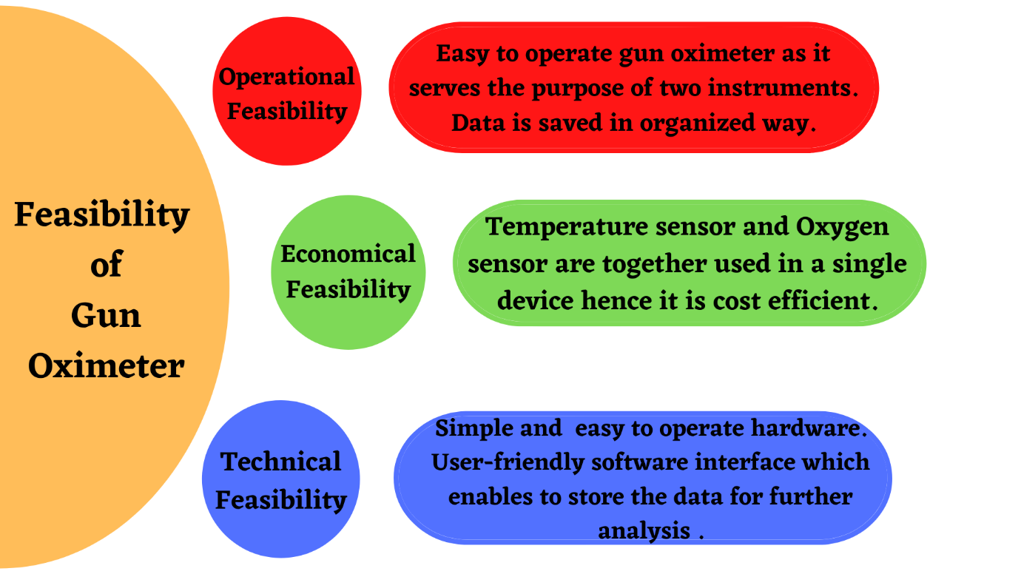

**Test Results and Analysis**

We have taken 10 readings using Gun Oximeter. About 90% of the temperature readings were accurate . The accuracy of temperature sensor of our device is quite good . The readings of the Spo2 sensor fluctuated at times. Invalid readings were captured.

Accuracy of temperature sensor is better than Spo2 sensor.

For the software part we used Django as Web framework and My SQL as Database.

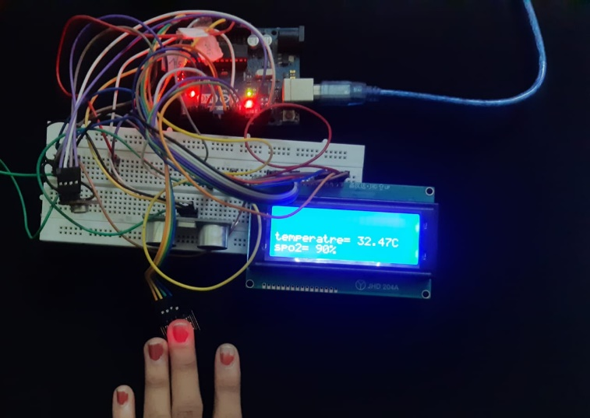

Readings using hardware



**Fig 7** Temperature accuracy graph

**Fig.8** Oxygen accuracy graph

The 10 readings were saved in the Database as shown below.

In these 10 readings accuracy of temperature sensor is very high as compare to spo2 sensor.

Spo2 sensor readings are fluctuating as you can see reading no 7.

Temperature sensor readings were accurate.

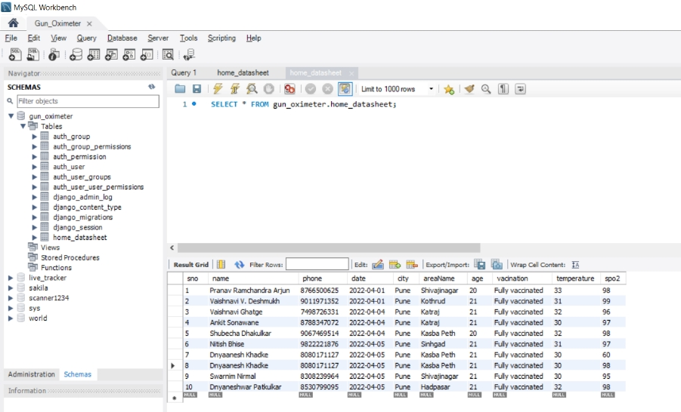

**Fig 9** My SQL Database Workbench

**Challenges and Problems faced**

1. The sensors not showing accurate readings at times due to fluctuations.
2. Delay in outputs. (eg MAX30102 takes 50 samples)
3. Looping the functioning of the three sensors simultaneously.
4. Power and memory management of prototype and Arduino board.

**CONCLUSION**

We have built an IOT based project . This project is divided into two main parts . Hardware and Software. We have built a device which can measure temperature and oxygen . Moreover this data will be store on MySql database. We have Arduino as our microcontroller to interface with the sensors.

For the storing part we have developed a webpage which can store the person’s readings along with the information. This data will be further analyzed for future uses.

**References:**

Quast, S.; Kimberger, O. The Significance of Core Temperature—

Pathophysiology and Measurement Methods; Dräger Medical GmbH:

Lübeck, Germany, 2014.

[2] http://www.ces.fau.edu/nasa/module-2/correlation-between-

temperature-and-radiation.php

[3] Hsuan-Yu Chen, Andrew Chen, Chiachung Chen, Investigation of the

Impact of Infrared Sensors on Core Body Temperature Monitoring by

Comparing Measurement Sites, MDPI, Basel, Switzerland, May 2020

Quast, S.; Kimberger, O. The Significance of Core Temperature—

Pathophysiology and Measurement Methods; Dräger Medical GmbH:

Lübeck, Germany, 2014.

[2] http://www.ces.fau.edu/nasa/module-2/correlation-between-

temperature-and-radiation.php

[3] Hsuan-Yu Chen, Andrew Chen, Chiachung Chen, Investigation of the

Impact of Infrared Sensors on Core Body Temperature Monitoring by

Comparing Measurement Sites, MDPI, Basel, Switzerland, May 2020

1. Quast, S.; Kimberger, O. The Significance of Core Temperature— Pathophysiology and Measurement Methods; Dräger Medical GmbH: Lübeck, Germany, 2014.
2. http://www.ces.fau.edu/nasa/module-2/correlation-betweentemperature-and-radiation.php
3. Hsuan-Yu Chen, Andrew Chen, Chiachung Chen, Investigation of the Impact of Infrared Sensors on Core Body Temperature Monitoring by Comparing Measurement Sites, MDPI, Basel, Switzerland, May 2020
4. Jubran A. Pulse oximetry. *Crit Care.*2015;19 [[PMC free article](https://www.ncbi.nlm.nih.gov/pmc/articles/PMC4504215/)] [[PubMed](https://www.ncbi.nlm.nih.gov/pubmed/26179876)] [[Google Scholar](https://scholar.google.com/scholar_lookup?journal=Crit+Care&title=Pulse+oximetry&author=A.+Jubran&volume=19&publication_year=2015&)]
5. Soar J., Nolan J.P., Böttiger B.W. European Resuscitation Council guidelines for resuscitation 2015: section 3. Adult advanced life support. *Resuscitation.*2015;95:100–147. [[PubMed](https://www.ncbi.nlm.nih.gov/pubmed/26477701)] [[Google Scholar](https://scholar.google.com/scholar_lookup?journal=Resuscitation&title=European+Resuscitation+Council+guidelines+for+resuscitation+2015:+section+3.+Adult+advanced+life+support&author=J.+Soar&author=J.P.+Nolan&author=B.W.+B%C3%B6ttiger&volume=95&publication_year=2015&pages=100-147&pmid=26477701&)]
6. 3. Brennan C.E., Hong T.K.F., Wang V.J. Predictors of safe discharge for pediatric drowning patients in the emergency department. Am J Emerg Med. 2018;36:1619–1623. [PubMed] [Google Scholar]
7. Awad A.A., Stout R.G., Ghobashy M.A.M., Rezkanna H.A., Silverman D.G., Shelley K.H. Analysis of the ear pulse oximeter waveform. J Clin Monit Comput. 2006;20:175–184. [PubMed] [Google Scholar]
8. Montenij L.J., de Vries W., Schwarte L., Bierens J.J.L.M. Feasibility of pulse oximetry in the initial prehospital management of victims of drowning: a preliminary study. Resuscitation. 2011;82:1235–1238. [PubMed] [Google Scholar]
9. Wilson B.J., Cowan H.J., Lord J.A., Zuege D.J., Zygun D.A. The accuracy of pulse oximetry in emergency department patients with severe sepsis and septic shock: a retrospective cohort study. BMC Emerg Med. 2010;10:9. [PMC free article] [PubMed] [Google Scholar]
10. Das J., Aggarwal A., Aggarwal N.K. Pulse oximeter accuracy and precision at five different sensor locations in infants and children with cyanotic heart disease. Indian J Anaesth. 2010;54:531–534. [PMC free article] [PubMed] [Google Scholar]
11. Seifi S., Khatony A., Moradi G., Abdi A., Najafi F. Accuracy of pulse oximetry in detection of oxygen saturation in patients admitted to the intensive care unit of heart surgery: comparison of finger, toe, forehead and earlobe probes. BMC Nurs. 2018;17 [PMC free article] [PubMed] [Google Scholar]
12. Hinkelbein J., Genzwuerker H.V., Fiedler F. Detection of a systolic pressure threshold for reliable readings in pulse oximetry. Resuscitation. 2005;64:315–319. [PubMed] [Google Scholar]
13. Shah N., Ragaswamy H.B., Govindugari K., Estanol L. Performance of three new-generation pulse oximeters during motion and low perfusion in volunteers. J Clin Anesth. 2012;24:385–391. [PubMed] [Google Scholar]
14. Trivedi N.S., Ghouri A.F., Shah N.K., Lai E., Barker S.J. Effects of motion, ambient light, and hypoperfusion on pulse oximeter function. J Clin Anesth. 1997;9:179–183. [PubMed] [Google Scholar]
15. Durbin C.G., Rostow S.K. More reliable oximetry reduces the frequency of arterial blood gas analyses and hastens oxygen weaning after cardiac surgery: a prospective, randomized trial of the clinical impact of a new technology. Crit Care Med. 2002;30:1735–1740. [PubMed] [Google Scholar]**APPENDIX**

**APPENDIX**

\

Quast, S.; Kimberger, O. The Significance of Core Temperature—

Pathophysiology and Measurement Methods; Dräger Medical GmbH:

Lübeck, Germany, 2014.

[2] http://www.ces.fau.edu/nasa/module-2/correlation-between-

temperature-and-radiation.php

[3] Hsuan-Yu Chen, Andrew Chen, Chiachung Chen, Investigation of the

Impact of Infrared Sensors on Core Body Temperature Monitoring by

Comparing Measurement Sites, MDPI, Basel, Switzerland, May 2020

**A1 Bill of Material:**

1. Arduino Board-459/-
2. MLX90614 temperature sensor – 1500/-
3. LCD – 200/-
4. MAX30102 SPO2 sensor – 500/-
5. Distance Sensor- 300/-
6. Bread Board – 100/-
7. Jumper wires-100/-

**A2 Datasheets:**

1. **MAX30102 Datasheet**

**[** [**https://datasheets.maximintegrated.com/en/ds/MAX30102.pdf**](https://datasheets.maximintegrated.com/en/ds/MAX30102.pdf)**]**

1. **MLX90614**

**[https://www.sparkfun.com/datasheets/Sensors/Temperature/MLX90614_rev001.pdf]**

1. **Arduino UNO R3**

**[https://www.farnell.com/datasheets/1682209.pdf]**